**Portfolio website**

**Case study**

1Write a case study about your portfolio page that includes the following:

* Overview
* Context and Challenge
* Process and Insights
* Solution

2 Submit the following:

* A link to your published portfolio site
* A PDF file with your case study

**Overview**

The overview should be a short summary of your whole project. Someone who doesn’t want to read the whole case study should be able to understand the key parts of the project at a glance. It should include key takeaways such as the main problem, an overview of the solution, and the key results.

**Context and Challenge**

The second part of your case study should go into why you started the project in the first place. It gives the reader an understanding of the environmental factors and problems you wanted to solve within the project. It consists of three sections:

* **Background** and **description**: Contextual information about the project (e.g., purpose of the project, timelines, and so on).

**Context**

*Frontend development as specialization of my study in UI design studies.*

*Interface designers are more likely working closely with developers, so it necessary to understand each other language.*

*Revisiting my previous design work on my your portfolio site.*

**Purpose of the project :**

*Learning Html, CSS and Java Script language in order to create a responsive website, showcasing a well-curated design portfolio. As well as creating more online accessibilities by professional and future employers.*

And this would be a great opportunity to revisit my study cases and use the most of it, wrapped up within few visuals and explanatory text.

**Timelines**

*My role*

*UI & Frontend Development*

*Too I used :*

*Atom – GitHub – HTML – CSS – JavaScript*

*Duration: 1,5 months*

**The problem**: Clearly explain the “why”

*“As I want to work as a UX/UI designer in future, I know that I need to present my design skills to the world and to build a professional network.*

*As UI/UX designer I’m aware of the importance to understand the fundaments of HTML, CSS and Java Script language in order to think of my design on the developer point of view and also to be able to have better understanding of the developer’s work.*

*Currently, I don’t have an online presence in my design practice.*

**Goals**:

Every project you work on should have some tangible objectives (e.g., more traffic to the site, more downloads of a resource, etc.).

* *Being more visible and reachable from professional network as well as potential employers.*
* *A website that stands out and is more personal.*
* *Build a responsive website that will showcase design portfolio on my own   
  professional network.*
* *it’s become essential that you have a place to present your own work. Having a dedicated portfolio website allows to present the work I’ve done while showcasing my my technical skills.*
* *The portfolio website should have a distinct design that showcases a unique   
  style of work, as well as clean and well­written code.*

**Process and Insight**

This section is also very important. Here, you’ll elaborate on the design process, creative concept, and insight that led to your decisions. You can walk your readers through the research, workflow, and iterations of your project. In this section, you’ll show how you went from taking the challenge to finding a solution.

**Ideation**

Mockup based on my UI & UX design case studies

In the context of a portfolio website it is important to consider the average time a visitor would spend on it. // Visual //

Keyword : focus

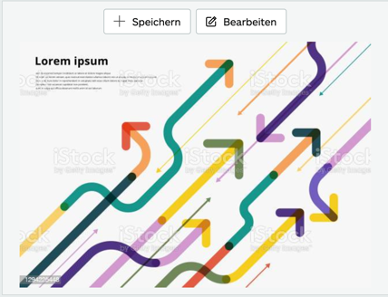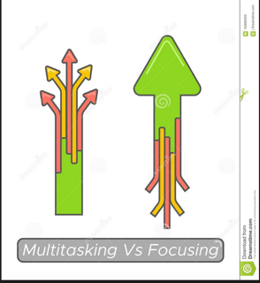

This means that what it is about, should be understood almost instantly and also generates enough curiosity in order to want to discover more of the projects.

Illustration

Loop icon

Process

? > searching > discovering > happy

Also, I needed to take in consideration the possibilities to adjust some design decision during the coding process of the learning phase, because I would understand more and more during what are the limitations during the coding.

Images

So I created some mockup wireframe with figma, and tried to keep it very simple/

Since the aim of this project is to learn Frontend development with Html, CSS and Java Script language, I wanted to learn the most of it by

See Images

Guideline & Styling

I wanted to have a very minimal approach in order to let the projects view vibrate by themselves and to enable neat user flow.

* + Color schemes

why Minimal approach for simple and clear read

* + Font /typography

Minimal and pleasant to read approach

* + Size and why

Proportionate size enable a good disctinction of the website structure

* + Logo :I to create a logo that would represent my artistic side and with a more individual touch: that why I used this handwriting typo
  + Navigation menu : I wanted a very straight forward navigation menu

**Learning coding**

Then I started using HTML coding with the help of the layout structure from the exercice.

In order to understand the HTML attribute and how to structure a page.

Syntax example + attribute illustration + some basic structure

Images

The visual enhancement with CSS

Image

And some basics of Java Script

Enabling a more user flow fluidity

User testing

After finalize the structure of the website and content

I conducte a user test within 5 participant in order to see if there are any text, user flows or interaction to adjust before the final launch of the website

**Solution**

Within the solution, you can show off your skills as designer. Here, you should feature all the samples of your work, from videos to screenshots. Don’t limit yourself to screenshots! Incorporate interactive elements such as animations or video walkthroughs—any medium that accurately represents your design work to really wow your readers.

Be sure to include written descriptions about your site’s features such as your navigation structure, content strategy, or the responsive experience. If you can write out your design decisions in detail, your readers will feel more confident about your skillset, and you will, too!

samples of your work

Showing the navigation

<!DOCTYPE html>

<html>

<body>

<video width="600" controls>

<source src="mov_bbb.mp4" type="video/mp4">

<source src="mov_bbb.ogg" type="video/ogg">

Your browser does not support HTML video.

</video>

<p>

Video courtesy of

<a href="https://www.bigbuckbunny.org/" target="_blank">Big Buck Bunny</a>.

</p>

</body>

</html>

**Results**

This section is all about the goals you defined at the beginning of your case study. You want to tell your readers which of the goals you’ve met and which other metrics you achieved with the solutions. Note that the results can only be included in a case study if the project has already launched and you’re publishing the case study a few weeks or months afterwards.